[emotion_articles.png] Percentage of News Article Emotions (Weighted by Social Media Score) by Time

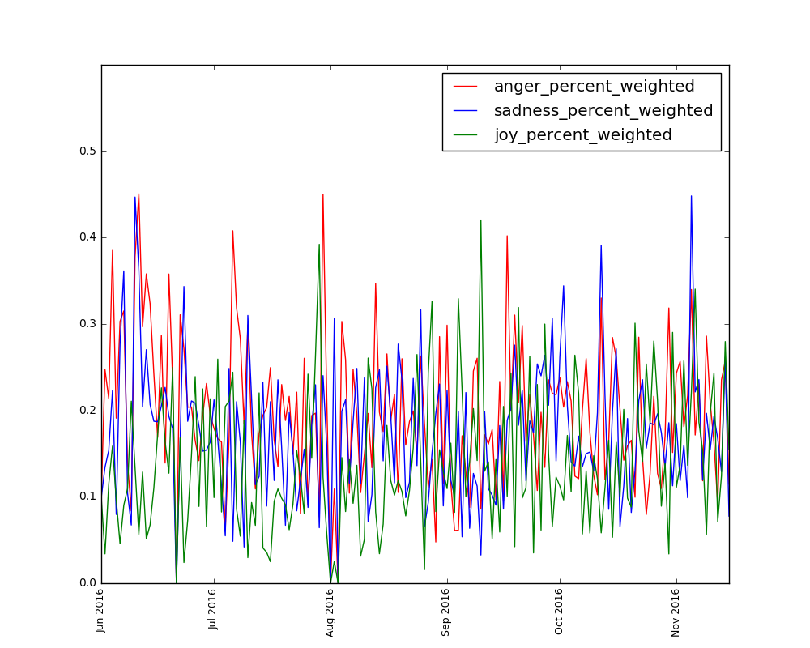

[emotion_streamed.png] Percentage of Spotify Song Playcounts (Clustered) by Time

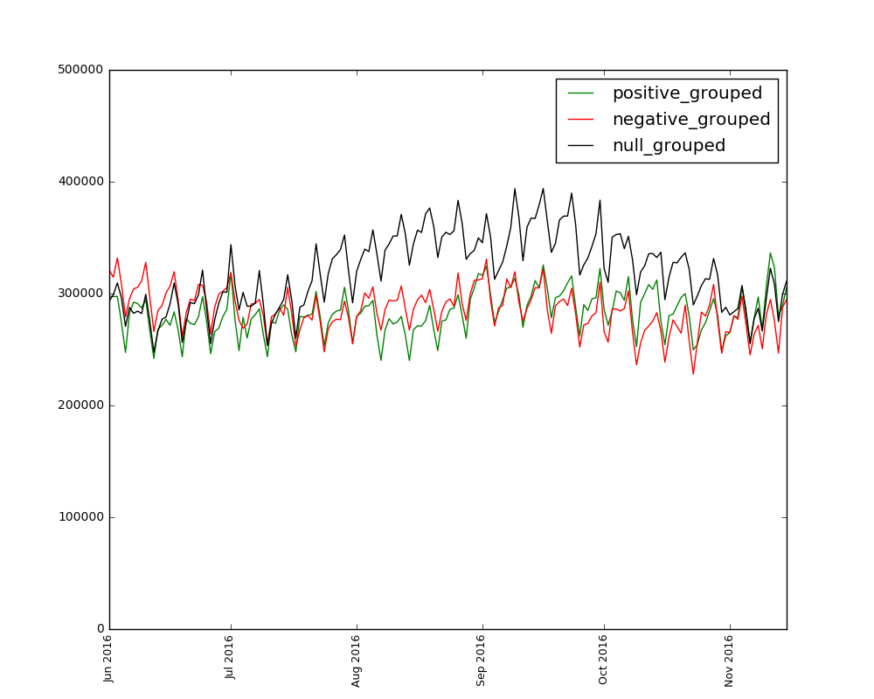

[kmeans_3Dscatterplot_songs] 3D Scatterplot of Spotify Songs (K-Means)

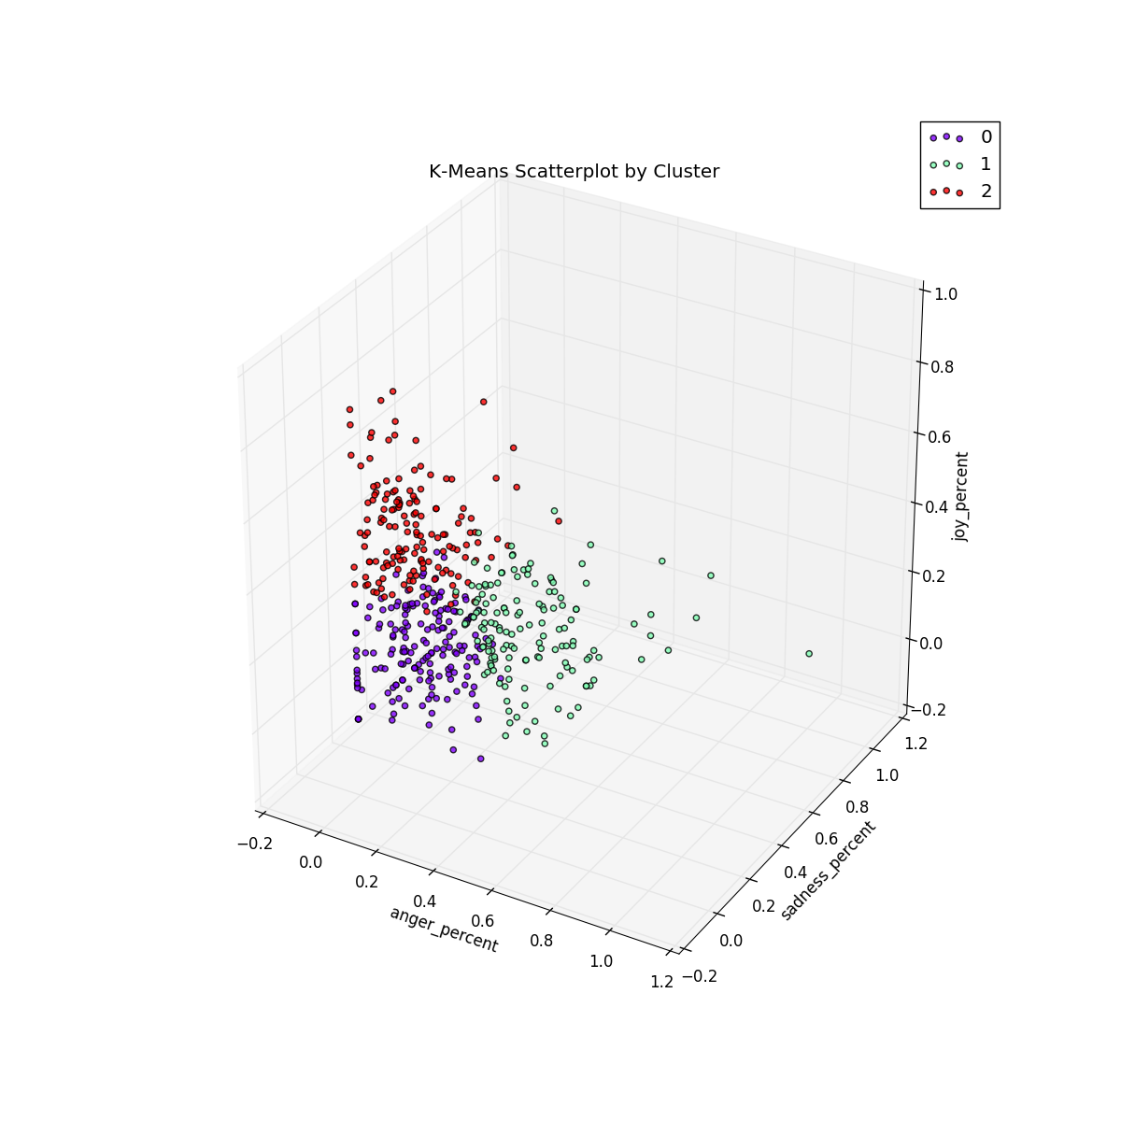

[nn_negative_anger.png] Percentage of News Article Emotions (Negative) Predicted by Article Anger Percent 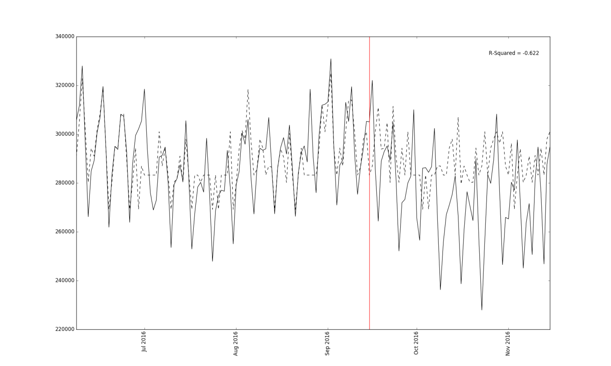

[nn_negative_joy.png] Percentage of News Article Emotions (Negative) Predicted by Article Joy Percent

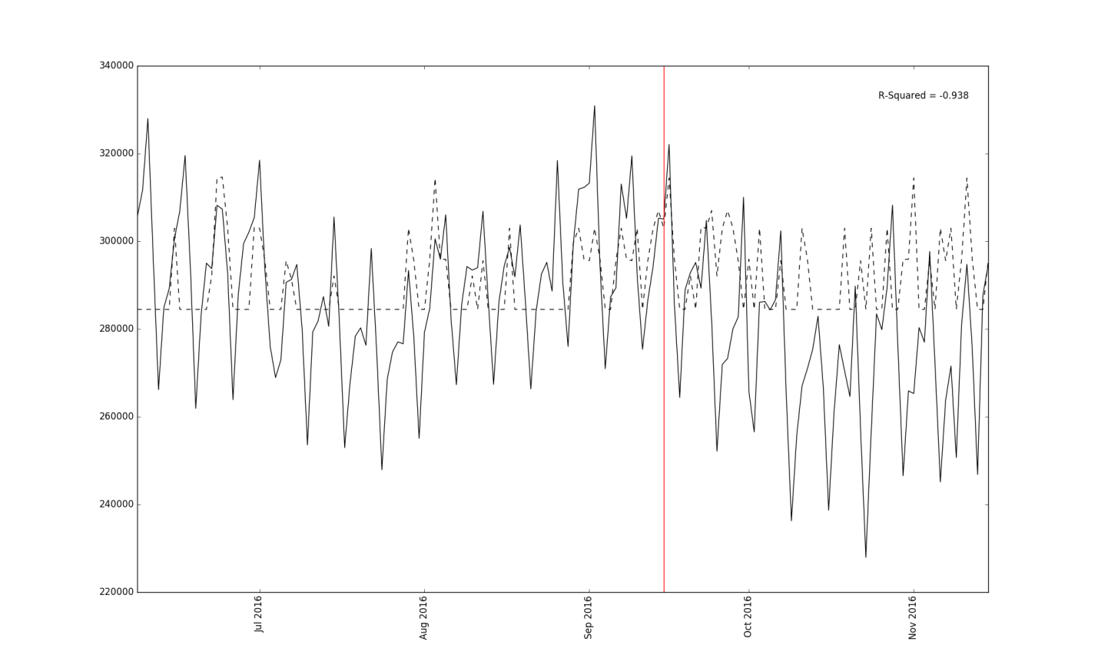

[nn_negative_sadness.png] Percentage of News Article Emotions (Negative) Predicted by Article Sadness Percent

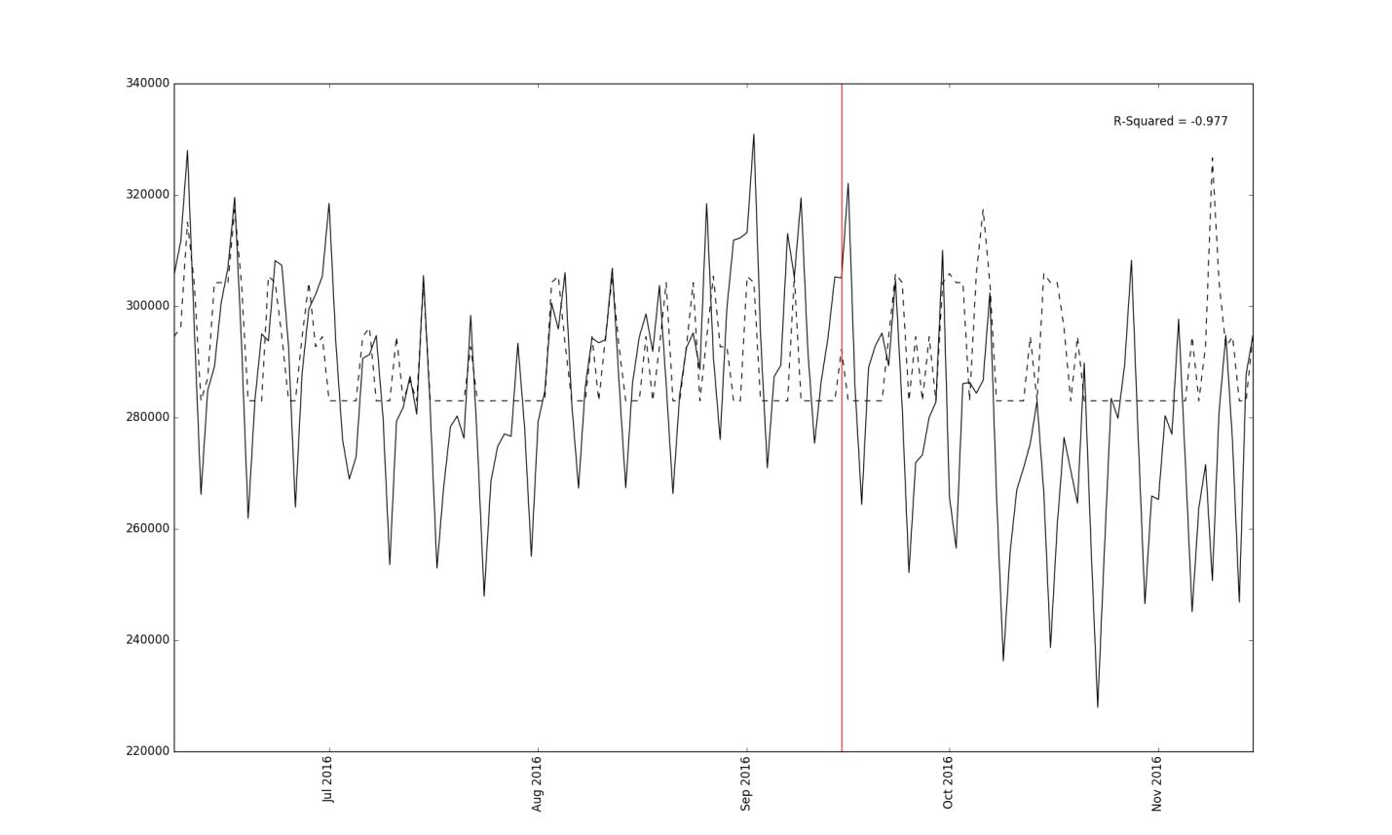

[nn_null_anger.png] Percentage of News Article Emotions (Null) Predicted by Article Anger Percent

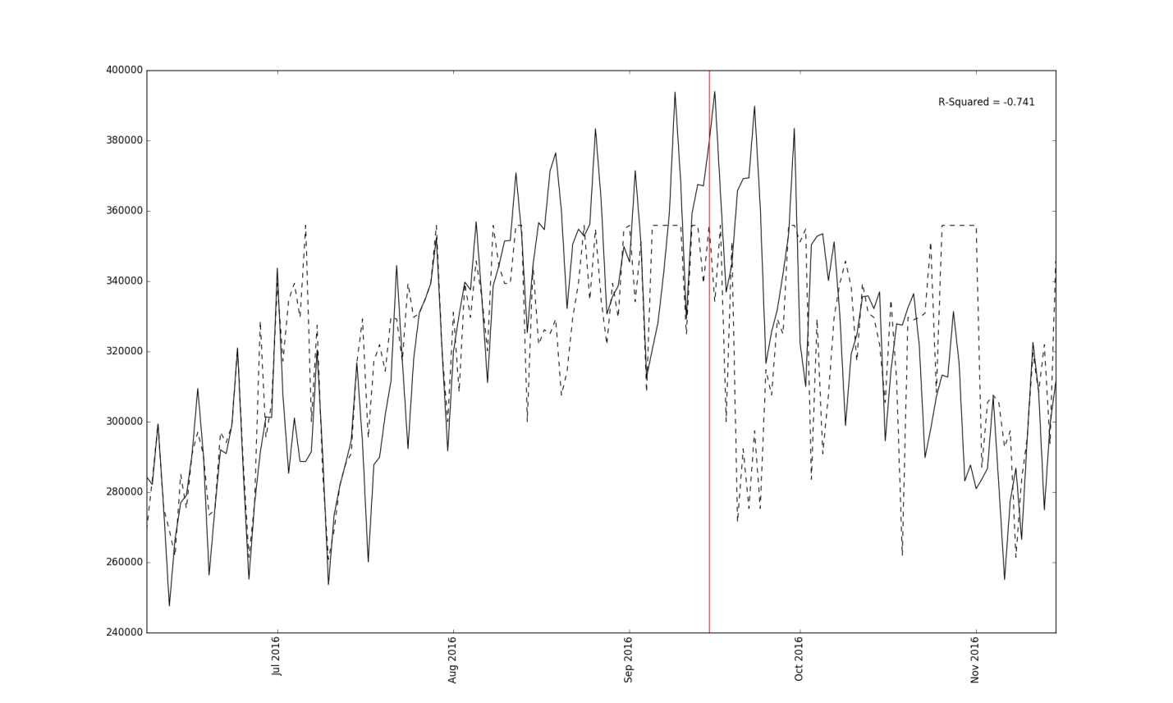

[nn_null_joy.png] Percentage of News Article Emotions (Null) Predicted by Article Joy Percent

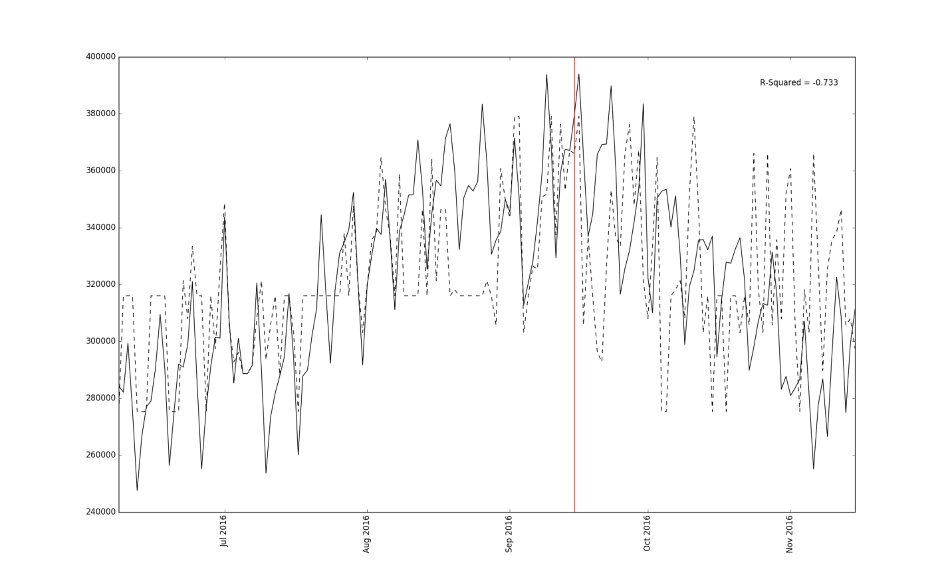

[nn_null_sadness.png] Percentage of News Article Emotions (Null) Predicted by Article Sadness Percent

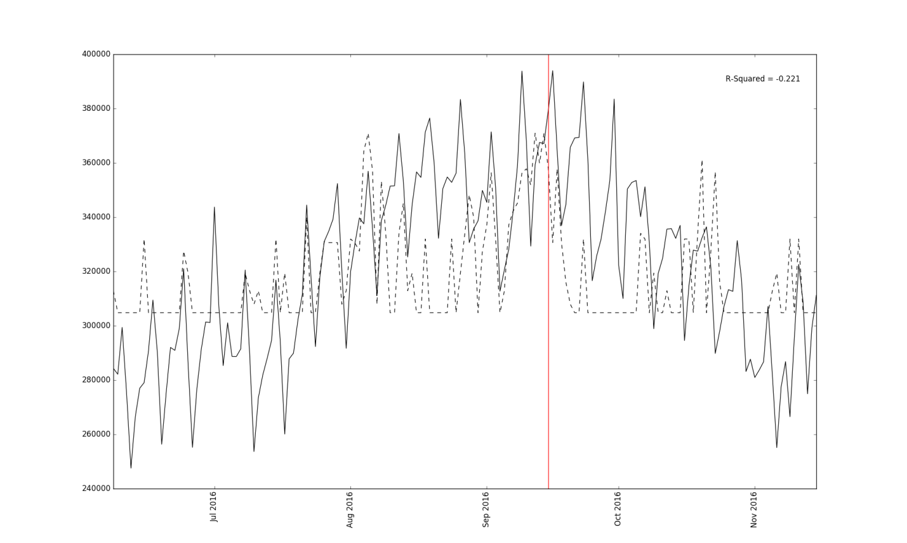

[nn_positive_anger.png] Percentage of News Article Emotions (Positive) Predicted by Article Anger Percent

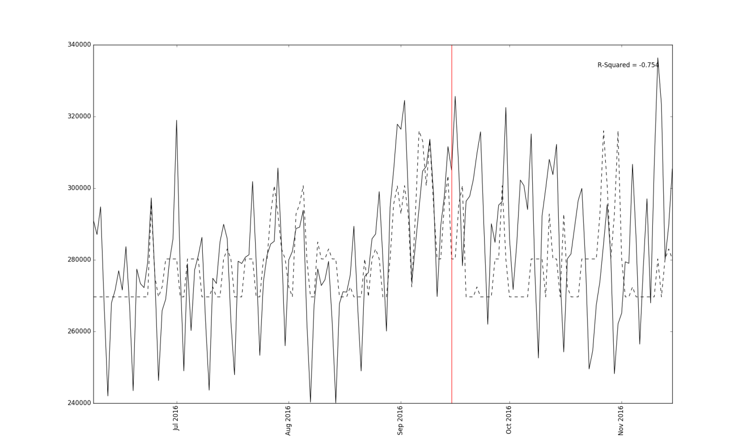

[nn_positive_joy.png] Percentage of News Article Emotions (Positive) Predicted by Article Joy Percent

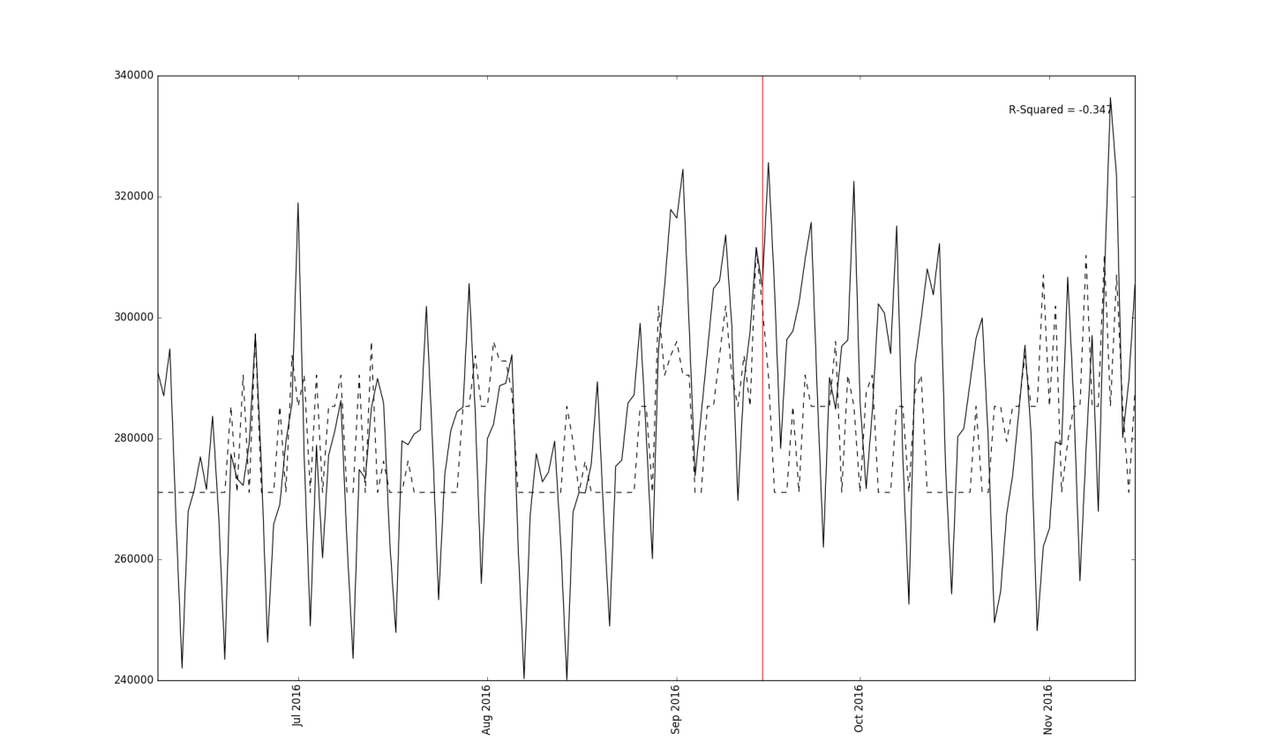

[nn_positive_sadness.png] Percentage of News Article Emotions (Positive) Predicted by Article Sadness Percent

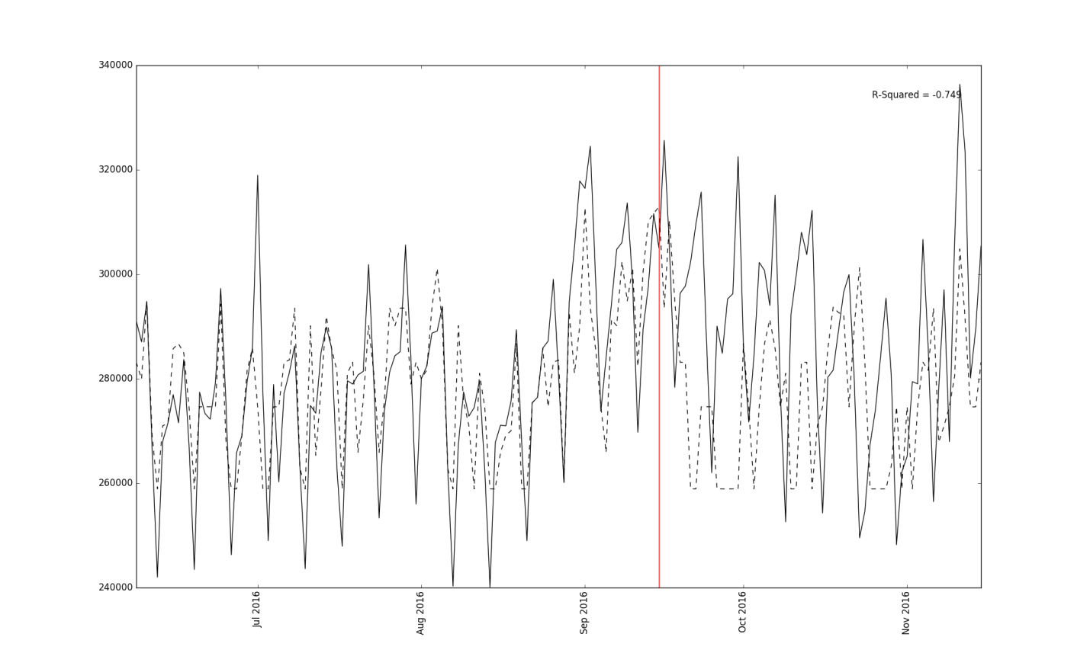

[ward_3Dscatterplot_songs.png] 3D Scatterplot of Spotify Songs (Ward)

